**Web Development - WEDE5020**

**Samukelo Mpofu**

**S10492840**

**Group 3**

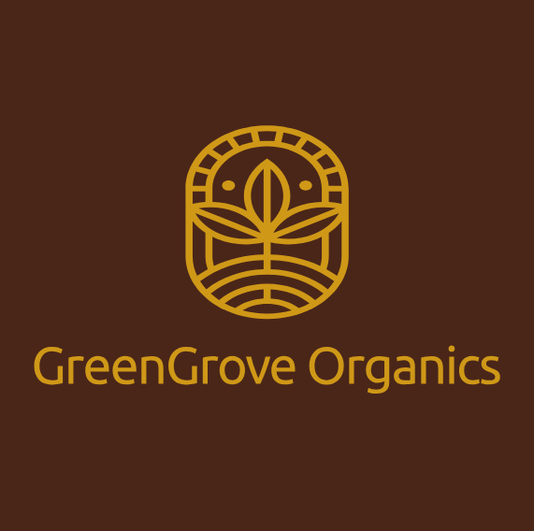

**Website Proposal**

**Table of Contents**

1. **Organisation Overview**
   * Name
   * Brief History
   * Mission Statement
   * Vision Statement
   * Target Audience
2. **Website Goals & Objectives**
   * Goals
   * Key Performance Indicators (KPIs)
3. **Current Website Analysis**
   * Strengths
   * Weaknesses
   * Areas for Improvement
4. **Proposed Website Features & Functionality**
   * Essential Features
   * Desired Functionality
5. **Design & User Experience**
   * Colour Scheme
   * Typography
   * Layout & Design Approach
   * User Experience Considerations
6. **Technical Requirements**
   * Hosting & Domain
   * Tech Stack
7. **Timeline and Milestones**
   * Project Phases
   * Key Deliverables
   * Submission Dates
8. **Budget**
   * Development Costs
   * Domain & Hosting
   * Maintenance
9. **References**

**1. Organisation Overview**

**Name:** GreenGrove Organics

**Brief History:**  
GreenGrove Organics started as a small family-run farmer’s market stand in 2015. Over time, it grew into a full-fledged brick-and-mortar store. Now, it’s looking to expand online to reach more customers.

**Mission Statement:**  
Deliver fresh, organic, and sustainably sourced produce while supporting local farmers.

**Vision Statement:**  
Become a top organic grocery brand with a seamless online shopping experience that promotes a sustainable, health-focused lifestyle.

**Target Audience:**

* Health-conscious individuals
* Families looking for organic options
* Restaurants and small businesses needing organic produce

**2. Website Goals & Objectives**

**Goals:**

* Create a user-friendly online store for browsing and purchasing organic products.
* Boost brand visibility and attract more customers.
* Educate consumers on the benefits of organic food.
* Offer subscription-based delivery services.

**Key Performance Indicators (KPIs):**

* Website traffic & engagement (bounce rate, session duration, click-through rate, etc).
* Conversion rate from visitors to buyers.
* Subscription sign-ups for regular produce deliveries.
* Customer feedback & reviews.

**3. Current Website Analysis**

GreenGrove Organics doesn’t have a website yet, so I looked at their competitors’ sites.

**Strengths:**

* Smooth navigation, clear product categorization, fast checkout.

**Weaknesses:**

* No personalized recommendations, slow loading times, poor mobile experience.

**Areas for Improvement:**

* A fast, mobile-optimized site.
* Personalized recommendations based on user history.
* A strong content strategy with blogs on organic living.

**4. Proposed Website Features & Functionality**

**Essential Features:**

* **Homepage** – Showcasing promotions, bestsellers, and sustainability efforts.
* **About Us** – The brand story, mission, and sourcing practices.
* **Product Catalog** – Categorized listings (fruits, veggies, dairy, etc).
* **Shopping Cart & Checkout** – Secure and user-friendly with multiple payment options.
* **Blog Section** – Articles on organic living, sustainability, and healthy recipes.
* **Contact Page** – Customer support.

**Desired Functionality:**

* Advanced search & filtering for easy product discovery.
* User accounts with order history & personalized recommendations.
* Secure payment gateway integration.
* Fully responsive, mobile-friendly design.

**Link to GitHub Repository:** [**CLICK HERE**](https://github.com/Rickeddy-7/GreenGrove)

**5. Design & User Experience**

**Colour Scheme:** Earthy greens & warm browns for a natural & sustainable feel.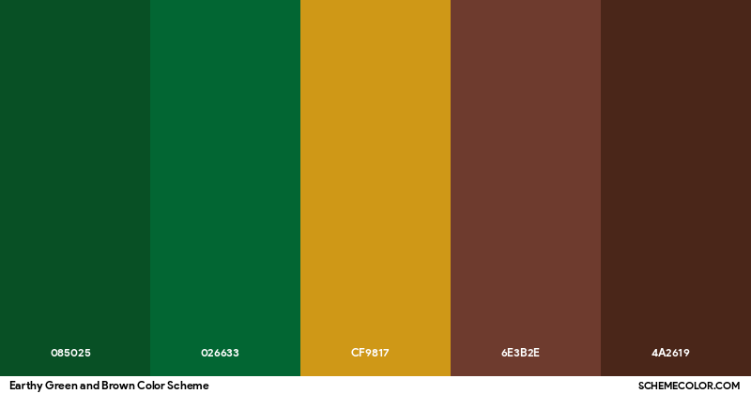

**Typography:**

* **Primary Font:** Ubuntu (organic, storytelling vibe).

**Layout & Design Approach:**

* Minimalist design with high-quality images.
* Grid-based product display for easy navigation.
* Clean, uncluttered look with good use of whitespace.

**User Experience Considerations:**

* Mobile-first design for seamless on-the-go shopping.
* Fast loading times for a smooth experience.
* Easy, hassle-free checkout with a guest checkout option too.

**6. Technical Requirements**

**Hosting & Domain:** GreenGroveOrganics.com hosted on AWS.

**Tech Stack:**

* **Frontend:** CSS, Bootstrap
* **Backend:** Java with Spring Boot.
* **Database:** MongoDB.

**7. Timelines and Milestones**

|  |  |  |  |
| --- | --- | --- | --- |
| **Phase** | **Description** | **Timeline** | **Milestone** |
| **Planning & Research** | |  |  | | --- | --- | | Finalizing file structure, goals, audience, and content requirements |  | | 11 – 24 March | |  | | --- | | 2 Project proposals & strategy ready | |
| **Submit Part 1** | Website proposal with full planning and basic HTML structure | 7 April | |  | | --- | | Part 1 submitted | |
| **Frontend Development** | CSS, JS, Bootstrap – core pages (Home, About, Blog, etc.) | 8 – 21 April | HTML, Basic structure & styling done |
| **Site Functionality** | Cart, subscription flow, form handling in JS | 22 – 30 April | Functionality complete |
| **Testing & Feedback** | Cross-browser testing, optimization | 1 – 3 May | QA complete |
| **Submit Part 2** | Final site delivery and walkthrough | **5 May** | Part 2 submitted |

**8. Budget**

|  |  |  |
| --- | --- | --- |
| Item | Cost | Description |
| **Domain Name Registration** | R660/year | Via EliteHost (R55 pm) |
| **Web Hosting (Static Site)** | ~ R700/year | AWS ($1-3 pm) |
| **SSL Certificate** | R1900/year | Elitehost Comodo EssentailSSL Wildcard |
| **Design & Development** | R5500 | Done in-house using HTML, CSS, JS |
| **Annual Maintenance** | R1,500/year | Includes updates, backups, and minor fixes |
| **Optional Email Setup** | R0 | Included in DNS subscription |

Total Estimated cost: R 10, 260

**9. References**

***Images*:**

* logo was created manually

JBT (no year) *Fresh Produce Solutions | FoodTech*. [Online image] Available at: https://www.jbtc.com/foodtech/products-and-solutions/solutions/fresh-produce (Accessed: 6 April 2025).

iStock (no year) *Shopping bag full of fresh vegetables and fruits stock photo*. [Online image] Available at: https://www.istockphoto.com/photo/shopping-bag-full-of-fresh-vegetables-and-fruits-gm1128687123-297902712 (Accessed: 6 April 2025).